6115-MAHENDRA INSTITUTE OF ENGINEERING AND TECHNOLOGY

*NOISE POLLUTION MONITORING*

TEAM: PROJ_223288_TEAM_1

TEAM ID : 570

Year : III

|  |
| --- |
| Team Members Name  YASVANTHRAJ.S  VIGNESHWARAN.M  VIGNESH.J  TAMIL SELVAN.A.D  SURESH.D  SURENDIRA BABU.D  Mentor Name  M.SANTHANARAJ |

Abstract

* Presently, noise pollution has become a very big issue around the world. The adverse effects of this pollution include hearing impairment, negative social behavior, annoyance, sleep disturbance and intelligibility to understand people’s speech. In learning context, noise can affect understanding and behavior of people and places with high noise level are not suitable for learning and teaching process.
* In near decades, the engineering and science professions have been hugely influenced by their responsibilities to the people. These responsibilities have send towards the protection of public welfare and healthcare. In the controls for emission of pollutants, engineers and scientists have created strategies for monitoring the environmental pollution problems.
* Environmental monitoring describes the activities and processes that should take place to monitor the quality of the environment. All strategies and techniques have justification and reasons which are often created to establish the status of an environment or to establish environmental parameter. In this paper, we have proposed an idea to monitor noise pollution using IoT Technique.
* The area covered by which the environment gets affected is noted andcontrol and prevention practice is implemented. By controlling the environmental noise pollution the cities are deprived of health issues.

Introduction

* Internet of things or commonly called IoT refers to the network of physical devices, vehicles, electronic appliances and other items embedded with sensors, software and connectivity which enables these things to connect, collect and exchange data without requiring human-to-human or human-to computer interaction.

* IoT is currently growing due to some factors such as convergence of multiple technologies, real time analytics, machine learning, commodity sensor and embedded systems. The term IoT was firstly coined by Kavin Ashton of Procter and Gamble and later by MITs Auto-ID centre (1999).
* Cisco System estimated that IoT was developed between 2008 and 2009. It is widely used in today’s applications such as consumer, commercial, industrial and infrastructure spaces. There is a lot of thing that can be implemented for the consumers’ daily uses.

* Take a smart home for instance, IoT is used in this invention to control lighting, heating, air-conditioning, media and security systems. This means it can save energy as it can automatically ensure lights and other electronics

Problem Statement

* Noise monitoring is very crucial since 20% of the European Union (EU) population or close to 80 million people suffer from noise level that experts consider to be unacceptable . IoT allows an exchange of information to and from a device or thing and due to its flexibility and low cost, IoT is getting popular day by day.
* Thus, IoT is very suitable to be implemented in monitoring the noise level in some areas to deal with the problem. The demands of modern society lead to the creation of noise sources such as industrial sources, transport vehicles, defence equipment and construction. The most significant example is inside UTM.
* Noise coming from vehicles and construction sites have significantly distract the focus and the intellectual development of the students. This issue results in the needs of a system that will monitor the noise level at that specified areas. It is also an alternative for students to know the suitability to study via app .

Literature Review

* IoT has been implemented in many noise monitoring systems nowadays including mobile phones and vehicles. These technologies were invented and developed because of the demand from society to have systematic and efficient system for monitoring purpose. With the use of cloud server, the users can access the data at anytime and anywhere . It is an effective way to reduce the work for authorities and less time consuming when recording data.
* The Noise Impact in the Learning-Teaching Process in an Elementary School Unnecessary or emission of noise that is coming from surrounding of school environment can become a barrier that distorts the communication within community inside the school. The aim of the project is to study the effect of noise from inside and outside of the school building also whether the noise can influence or not students’ performance in elementary school.
* World Health Organization (WHO) suggests that the maximum noise level and reverberation for school is 35dB for classrooms and 55dB for outdoor activities and the recommended reverberation time is 0.6 sec [14].

**Why is Noise Monitoring Important?**

* Noise monitoring is crucial for several reasons. First and foremost, it safeguards human health. Prolonged exposure to high levels of noise can lead to hearing loss and various physiological and psychological disorders, such as stress, sleep disturbances, and reduced productivity.
* Additionally, noise monitoring helps ensure compliance with legal regulations and standards set by authorities to protect workers’ well-being. Monitoring also identifies areas of concern, enabling proactive implementation of noise control measures to mitigate risks, improve working conditions, and maintain a harmonious environment for employees.
* Furthermore, noise monitoring contributes to good community relations, as industries that proactively manage noise pollution demonstrate their commitment to environmental responsibility and social welfare.

## Noise level Monitoring & Testing

* The answer to the question of how to measure sound lies in Noise level Monitoring or sound Measurement for a particular instance or for 24X7 hrs to analyze trends for better understanding of the environment. these Processes also used in Noise Impact Assessment (We love to do this ) by Noise level Testing companies. This process is also called as Noise level Measurement.

### Industrial Noise Measurement

* Industrial Noise is the loud sound in industries. In general, it is produced, at every stage in the industry by various aspects like welding, hammering, drilling, blowing, running machinery, motors, sheet metal work, lathe machine work, operation of cranes, grinding, turning, fabricating, forging, compressing, breaking, moulding, steaming, boiling, cooling, heating, venting, painting, pumping, packing, transporting etc. It creates very serious of large-scale noise problems; significantly affect the working people as well as surrounding people.

Non-Industrial Noise Measurement

Road Traffic Noise:

Road traffic is the most widespread source of the noise. It is directly proportional to the volume of vehicles. Increasing the population is increasing in vehicles and hence increasing of Noise pollution. The major sources of noise in automobiles are exhaust, intake, engine and fan, and tires at high-speed. Noise Level Monitor instrument (or with noise level data logger) measures the noise level*.*

Residential Noise Measurement:

In normal day –to – day activities, various home appliances in our residences produce noise. Some of the major sources are Exhaust Fans, lawn movers, grinders, Fan, Cooling & Heating System, T.V & Music System, motors used for pumping etc.

IoT Innovation in Noise Pollution Monitoring

* Learn about the revolutionary IoT innovation in noise pollution monitoring and why it's important for the world today. Noise pollution refers to the excessive or disruptive noise that can harm human health and disturb the natural balance of ecosystems.
* As urban areas grow and industrial activities expand, noise pollution becomes a critical concern. By leveraging the power of IoT, we can effectively monitor and manage noise levels to create healthier and more livable environments.
* Looking for strategies to deal with the never-ending cacophony of urban life? Are you interested in learning how the Internet of Things (IoT) can change real-time noise pollution monitoring in cities?
* Cities can now monitor noise pollution in real time thanks to the seamless integration of IoT devices, opening up a plethora of options.

Importance of Monitoring Noise Pollution

* It is important to monitor noise pollution to assess its impact on the community and the surrounding environment. Accurate data on the levels of noise pollution can help regulatory authorities enforce noise limits. Monitoring the noise levels can also help identify sources of noise pollution and develop mitigation measures.

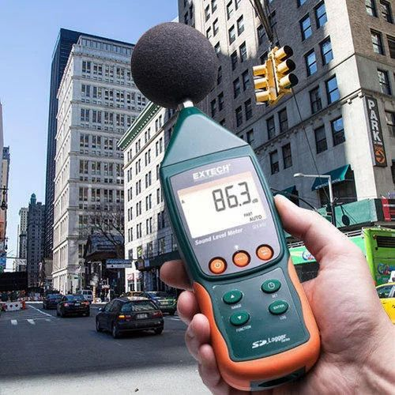

Challenges in Monitoring Noise Pollution

1. Costly Traditional Monitoring Methods

* The traditional noise monitoring methods involve the installation of static noise sensors, which can be costly and

ineffective in remote areas or areas with irregular sound patterns.

1. Data Accuracy

* The accuracy of the collected data might be questionable, giving misleading information and hindering the noise pollution control efforts of regulatory agencies and communities.

1. Limited Accessibility

* Noise data cannot be easily accessible to the public leading to a lack of transparency and citizen participation in monitoring environmental noise pollution.

IoT Innovation in Noise Pollution Monitoring

|  |  |
| --- | --- |
| IoT sensors: | Adoption of IoT sensors that analyze sound frequency and intensity, which can be used to capture and analyze environmental noise pollution data. |
| Real-time Access: | IoT devices can provide real-time access to noise pollution data on a webserver enabling the concerned stakeholders to access the data and take necessary actions promptly. |
| Predictive Analytics: | The noise pollution data collected via IoT can be further analyzed utilizing predictive analytics to estimate the future pattern of the noise levels. |
| Low-Cost Monitoring: | IoT sensors are significantly less expensive when compared to static monitoring devices thereby offering cost-effective monitoring solutions to individuals and communities. |

Effects of Noise Pollution

* Noise pollution has far-reaching consequences on both human health and the environment. Prolonged exposure to high noise levels can lead to hearing loss, cardiovascular problems, and mental health issues.Additionally, wildlife and ecosystems can be disrupted, affecting the behavior, communication, and survival of various species.

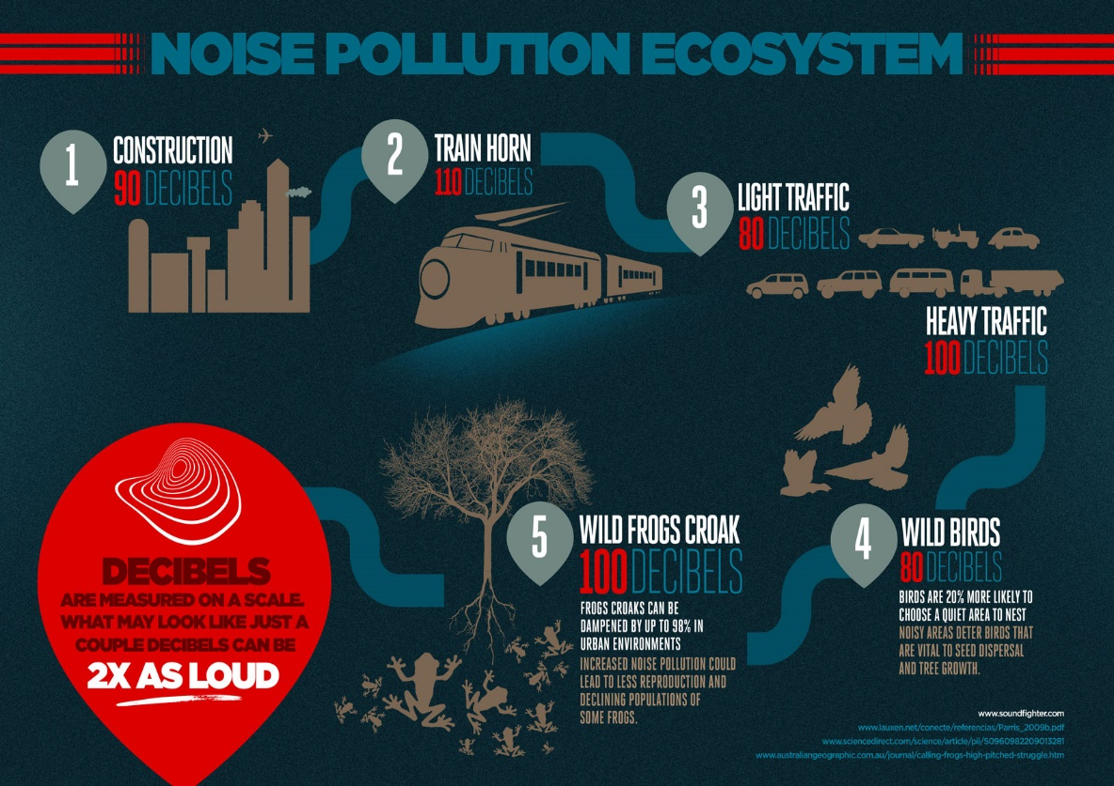

Internet of Things (IoT) and its Potential for Noise Pollution Monitoring

* IoT technology enables the connection and communication of various devices, sensors, and systems through the internet. Leveraging this connectivity, we can develop smart solutions for noise pollution monitoring and control.
* By deploying IoT devices with built-in noise sensors, we can collect real-time data on noise levels and patterns across different locations.This data can be analyzed and visualized to gain insights, identify noise hotspots, and inform effective mitigation strategies

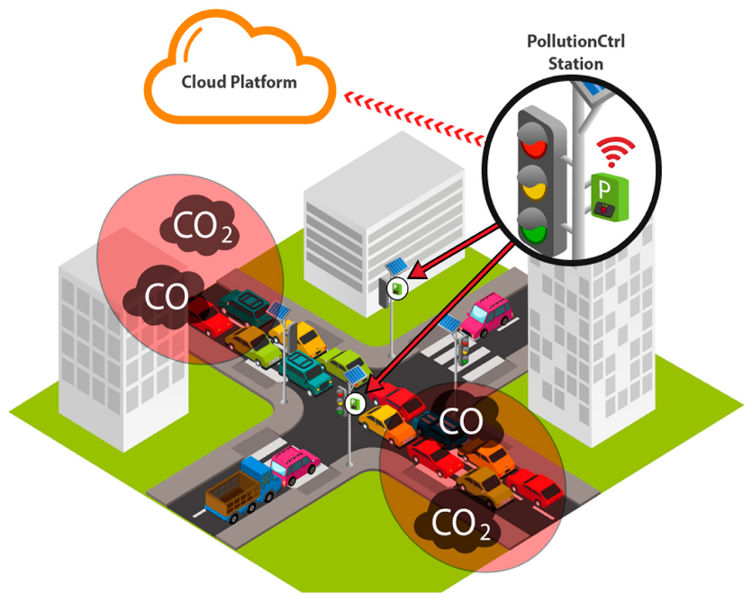

Objectives of the Program

1. Reducing Noise Pollution

We aim to reduce noise pollution levels by collecting and analyzing data on ambient noise levels and identifying areas where noise levels exceed the recommended limits.

1. Protecting Public Health

Our program aims to protect public health by reducing the impact of noise pollution on the human body. We hope to create a healthier and more productive environment.

1. Promoting Awareness and Education

Our program aims to promote awareness and education on noise pollution, its causes, and its consequences. We hope to educate people on the dangers of noise pollution and ways to reduce it.

How IoT Devices Enable Real-Time Noise Monitoring

* IoT devices, equipped with sound sensors and connectivity features, can be strategically deployed throughout urban areas to monitor noise levels continuously. These devices capture audio data and transmit it to a central system for analysis.

The data can then be processed in real-time to assess noise patterns, identify hotspots, and trigger alerts or notifications when noise levels exceed predefined thresholds. This enables authorities to respond promptly, implement noise reduction measures, and create quieter and more livable urban environments.

INSTALLATION

There are several ways to install noise pollution monitoring systems. The installation process depends on the type of system you are using and the location where it will be installed. Here are some general steps that can be followed:

**Choose the right location**: The location of the monitoring system is crucial. It should be installed in an area where noise pollution is a concern, such as near a busy road or construction site.

**Select the right equipment**: There are many different types of equipment available for noise pollution monitoring. Choose the one that best suits your needs and budget.

**Install the equipment**: Once you have selected the equipment, follow the manufacturer’s instructions to install it correctly.

**Calibrate the equipment**: Calibration is essential to ensure that the equipment is measuring noise levels accurately. Follow the manufacturer’s instructions to calibrate the equipment.

[**Connect to IoT platform**: If you are using an IoT-based noise pollution monitoring system, connect it to an IoT platform such as Blynk or Thingspeak](https://cpcb.nic.in/guidelines/) .

**Monitor and analyze data**: Once the system is installed and connected, you can start monitoring and analyzing data. This will help you identify areas where noise pollution is high and take appropriate measures to reduce it.

Please note that these are general steps, and the installation process may vary depending on the type of system you are using.

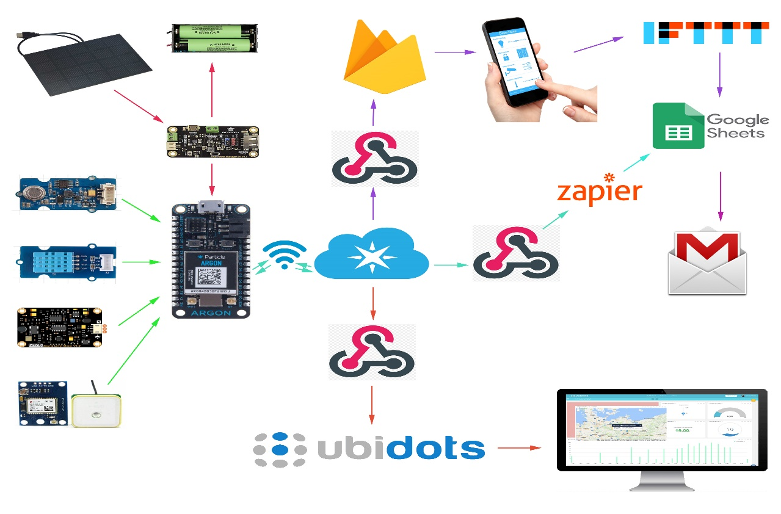

PLANNING

[There are several strategies and implications of noise pollution monitoring, modelling, and mitigation in urban cities](https://link.springer.com/referenceworkentry/10.1007/978-981-19-1550-5_86-1) . [The present chapter provides an exhaustive review on the noise monitoring studies, comparison of the prediction models including physical propagation model, and applications of the artificial intelligence techniques, noise mapping, and noise pollution monitoring in mining sector carried out by various researchers](https://link.springer.com/referenceworkentry/10.1007/978-981-19-1550-5_86-1) .

Noise prediction models play a vital role in city planning for control and abatement of noise pollution. [Therefore, a lot of mathematical/hybrid/artificial intelligence models had been developed in past years introducing sound propagation and sound specific emission empirical formulation](https://link.springer.com/referenceworkentry/10.1007/978-981-19-1550-5_86-1) .

In terms of planning for installation of noise pollution monitoring systems, there are several steps that can be followed. [These include choosing the right location, selecting the right equipment, installing the equipment, calibrating the equipment, connecting to an IoT platform if applicable, and monitoring and analyzing data](https://www.gov.uk/government/collections/noise-management) . Please note that these are general steps, and the installation process may vary depending on the type of system you are using.

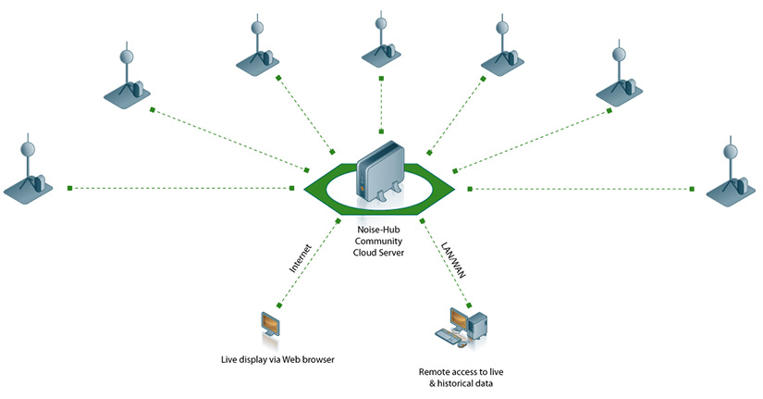

EXECUTION

The main objective of this work is the development of a Vehicle Ad Hoc NETwork (VANET) to collect data from GPS equipped mobile phones used as noise detectors. In this system, sensor nodes perioadically transmit acoustic noise levels to neighboring cars, data packets being shared and temporary stored by participating VANET nodes and ultimately forwarded to a collector node connected to the Internet, providing public real-time data. A routing technique called MP-OLSR that takes into account the spatially separation between the multiple paths is used, for better transmission reliability and congestion avoidance as well as for control message overhead minimization.

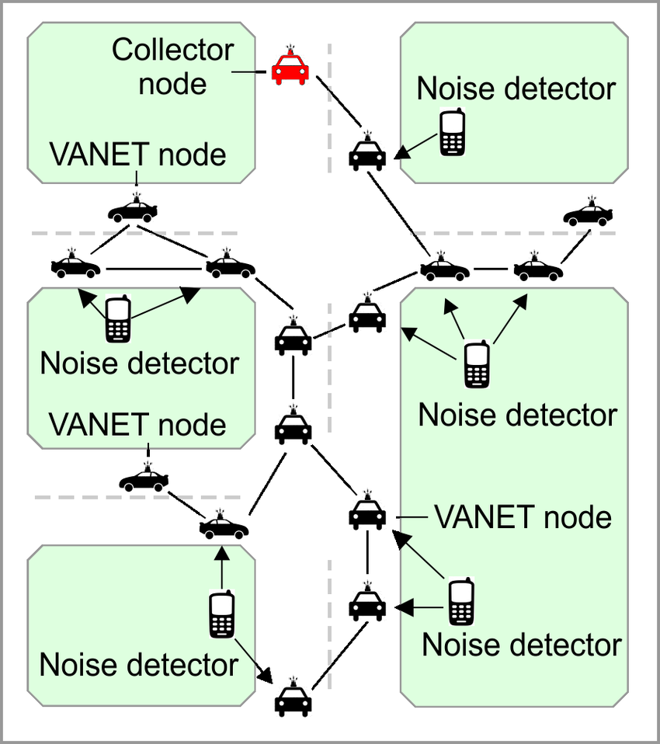

Controlling

There are several ways to control noise pollution. [The Central Pollution Control Board (CPCB) in India has implemented the Noise Pollution (Regulation and Control) Rules, 2000 to regulate and control noise-producing and generating sources](https://cpcb.nic.in/noise-pollution-rules/) . [The authority is responsible for enforcing noise pollution control measures and ensuring compliance with ambient air quality standards in respect of noise](https://cpcb.nic.in/noise-pollution-rules/) . [The use of loudspeakers and public address systems is restricted under these rules](https://cpcb.nic.in/noise-pollution-rules/) .

In addition to regulatory measures, there are several other ways to control noise pollution. [These include designing quieter machines, using acoustic enclosures and vibration isolators, increasing the distance of transmission, and using noise-canceling headphones or earplugs](https://prepp.in/news/e-492-measures-to-control-noise-pollution-environment-notes) .

The book Environmental Noise Control: The Indian Perspective in an International Context provides an extensive review of recent studies, including references, and describes the latest noise monitoring structures. [It also addresses heretofore under-emphasized topics, including but not limited to acoustic metrology, Multi Attribute Decision Making (MADM) techniques, and sound insulation utilizing passive control strategies](https://link.springer.com/book/10.1007/978-3-030-87828-3) .

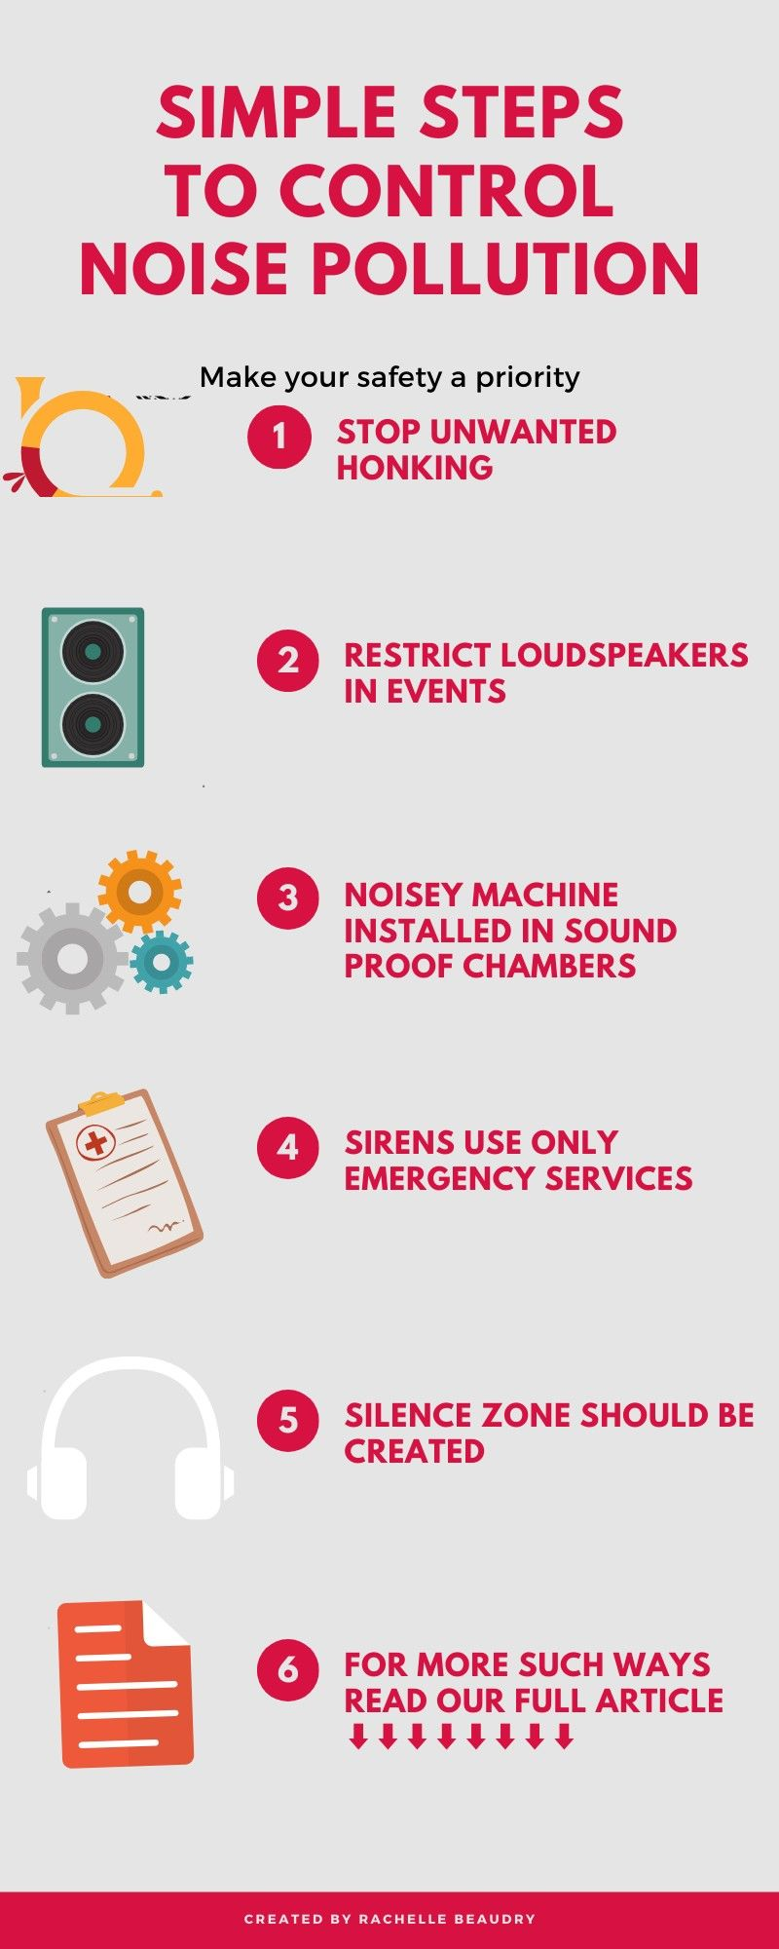

**Monitoring Construction Site Noise Limits**

The noise conditions set for the site were complex, with different noise levels being permitted at different times of day and night and with separate noise conditions for Saturdays, Sundays and Bank Holidays.

The client required that if any of the noise limits for the site were breached, or if the site was getting near its permitted cumulative noise levels for the day, alerts would be sent to a number of different parties.

Initialization

In this guide, we will explore the importance of noise pollution monitoring and its various types and effects. We will also delve into the methods used for monitoring noise pollution and discuss the benefits of implementing such monitoring systems. By the end, you will have a comprehensive understanding of why noise pollution monitoring is crucial in today's world.

**The Objective: Maintaining Serenity**

Noise pollution monitoring aims to preserve the tranquility of our environment. By measuring and analyzing sound levels, we can identify potential sources of noise pollution and implement appropriate solutions. Whether it is reducing traffic noise or minimizing industrial disturbances, the objective of noise pollution monitoring is to create a peaceful and harmonious atmosphere for all.

Understanding Noise Pollution

Environmental Noise

Environmental noise pollution includes sounds from transportation, construction, and recreational activities. By monitoring these sources, we can mitigate their impact on both wildlife and human health.

Industrial Noise

Industrial noise pollution arises from factories, generators, and machinery. By closely examining the noise levels in such settings, we can protect workers' hearing and ensure compliance with noise regulations.

Community Noise

Community noise sources like loud music, barking dogs, and noisy neighbors can disrupt the peace of residential areas. Monitoring community noise allows us to address specific issues affecting local communities.

# Unmasking the Effects of Noise Pollution

|  |  |  |
| --- | --- | --- |
| Health Effects | Environmental Degradation | Social Disruption |
| Noise pollution can lead to stress, sleep disturbances, and cardiovascular problems. | Excessive noise can harm wildlife, disrupt ecosystems, and impact natural habitats. | Noise pollution hampers communication, contributes to irritability, and impairs concentration. |

The Sound of Measurement

"The decibel meter, a vital tool in noise pollution monitoring, takes the whispers of the environment and transforms them into actionable data."Through decibel meters and sound level monitors, we can objectively measure noise levels and establish baseline thresholds for different environments. These devices enable quantitative analysis and serve as the foundation for effective noise pollution management strategies.

Elevating Noise Pollution Monitoring

Preventative Measures

By monitoring noise pollution, we can take proactive steps to minimize its occurrence through better urban planning, effective noise barriers, and technological advancements in noise-reducing equipment.

#### Regulatory Compliance

Noise monitoring is crucial in ensuring compliance with noise regulations, protecting public health, and maintaining a harmonious coexistence between industrial activities and communities.

#### Improved Quality of Life

Implementing noise pollution monitoring enhances the overall well-being of individuals and communities by creating quieter and more comfortable living and working environments.

# Data Collection and Analysis

"Data is the new oil." With noise pollution monitoring, data collection and analysis play a vital role in understanding the problem and developing effective strategies. By analyzing noise patterns, sources, and trends, we can make informed decisions and implement targeted solutions to combat noise pollution.

Technology Used in Noise Pollution Monitoring

#### Sound Level Meters

#### Measure sound pressure levels in decibels (dB) and record data for analysis.

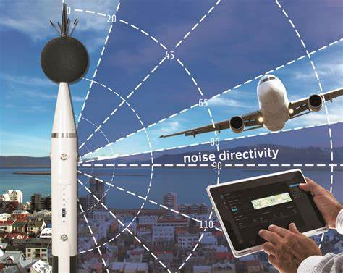

#### Noise Monitoring Software

Collects and analyses noise data, helps in generating reports, and assists in decision-making.

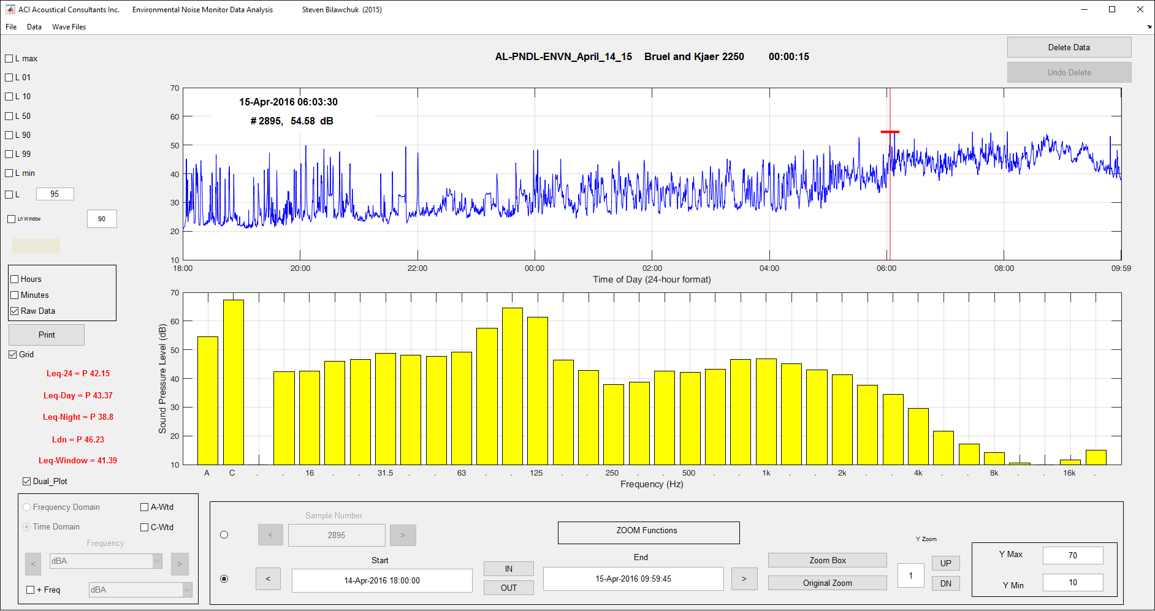

#### Noise Mapping Software

Visualises noise data by generating noise maps and helping in identifying noise hotspots.

# 

Advantages of Using IoT for Noise Pollution Monitoring



Real-time Monitoring

IoT enables continuous and real-time monitoring of noise levels, providing upto-date information for timely interventions and improvements.

Data Accuracy

IoT sensors provide accurate measurements, eliminating the need for human intervention and reducing errors in data collection.

Cost Efficiency

IoT systems can be costeffective compared to traditional monitoring methods, reducing operational costs and enabling wider deployment.

Disadvantages of Using IoT for Noise Pollution Monitoring

Data Security Risks

IoT systems are vulnerable to cyber threats, potentially compromising the integrity and confidentiality of collected data.

Infrastructure Requirements

Implementing an IoT infrastructure for noise pollution monitoring can require significant investments in equipment and network capabilities.

Accessibility Challenges

Not all areas have reliable network coverage, limiting the scalability and reach of IoT-based noise monitoring systems.

Overcoming Challenges in IoT-Based Noise Monitoring

### 1. Ensuring Data Accuracy and Reliability

To ensure the accuracy and reliability of data collected by IoT devices, careful calibration and maintenance are essential. Regular calibration checks and sensor upkeep help maintain the precision of measurements and minimize inaccuracies. Quality control measures should be implemented to identify and address any anomalies or sensor malfunctions promptly.

### 2. Addressing Privacy Concerns

IoT-based noise monitoring systems involve the collection of audio data, raising privacy concerns among individuals. To address these concerns, strict data protection protocols and anonymization techniques can be implemented. By removing personal information and adhering to privacy regulations, the data collected can be used solely for noise analysis and urban planning purposes.

### 3. Dealing with Data Overload

IoT devices generate a vast amount of data, and managing and analyzing this data can be overwhelming. Implementing robust data storage and processing solutions, such as cloud-based platforms, can handle the large volume of data generated by IoT devices.

Employing data analytics tools and machine learning algorithms can help extract valuable insights from the data, facilitating effective decision-making.



DATASET(JAVA)

import java.util.Scanner;

public class NoisePollutionMonitoring

{

public static void main(String[] args)

{

Scanner scanner = new Scanner(System.in);

System.out.println("Noise Pollution Monitoring System");

System.out.println("--------------------------------");

int noiseLevel;

// Variable to store noise level

// Reading and monitoring noise levels until user enters -1 to quit

while (true)

{

System.out.print("Enter the noise level (-1 to quit): ");

noiseLevel = scanner.nextInt();

if (noiseLevel == -1) {

System.out.println("Monitoring system stopped.");

break;

}

// Perform noise pollution analysis based on the noise level

if (noiseLevel <= 45)

{

System.out.println("Noise level is within acceptable limits.");

}

else if (noiseLevel > 45 && noiseLevel <= 70) {

System.out.println("Noise level is moderately disturbing.");

}

else if (noiseLevel > 70 && noiseLevel <= 90) {

System.out.println("Noise level is very disturbing. Take precautions!");

}

else

{

System.out.println("Noise level is extremely disturbing. Immediate action required!");

}

}

scanner.close();

}}

OUTPUT

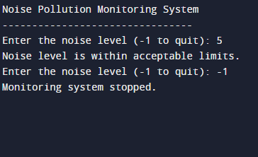

|  |
| --- |
| THANK YOU |